R3.3 Change List
- Chromecast services are temporarily unavailable
- Airplay/ Miracast enable PIN for authentication
- Direct Connect (WiDi) for Miracast
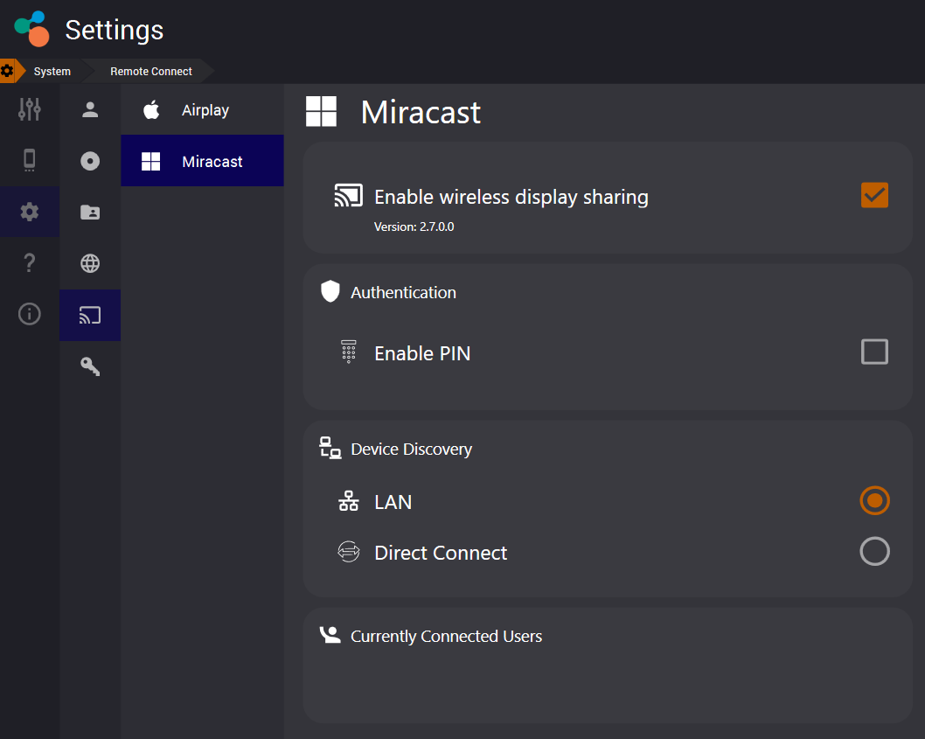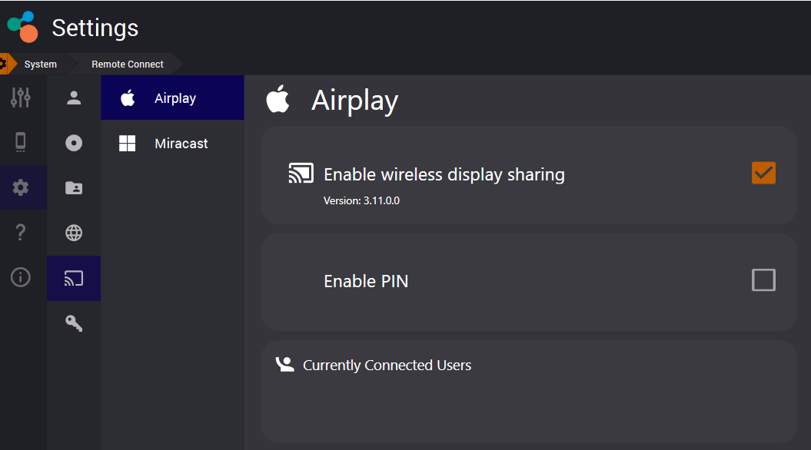

- New Shortcut CTRL + T. Use CTRL+T to restore the scatter item toolbar. It resets/restores the Toolbar default position and shows it.
- New Double click behaviour on files and folders. First click highlights file, second click will select.
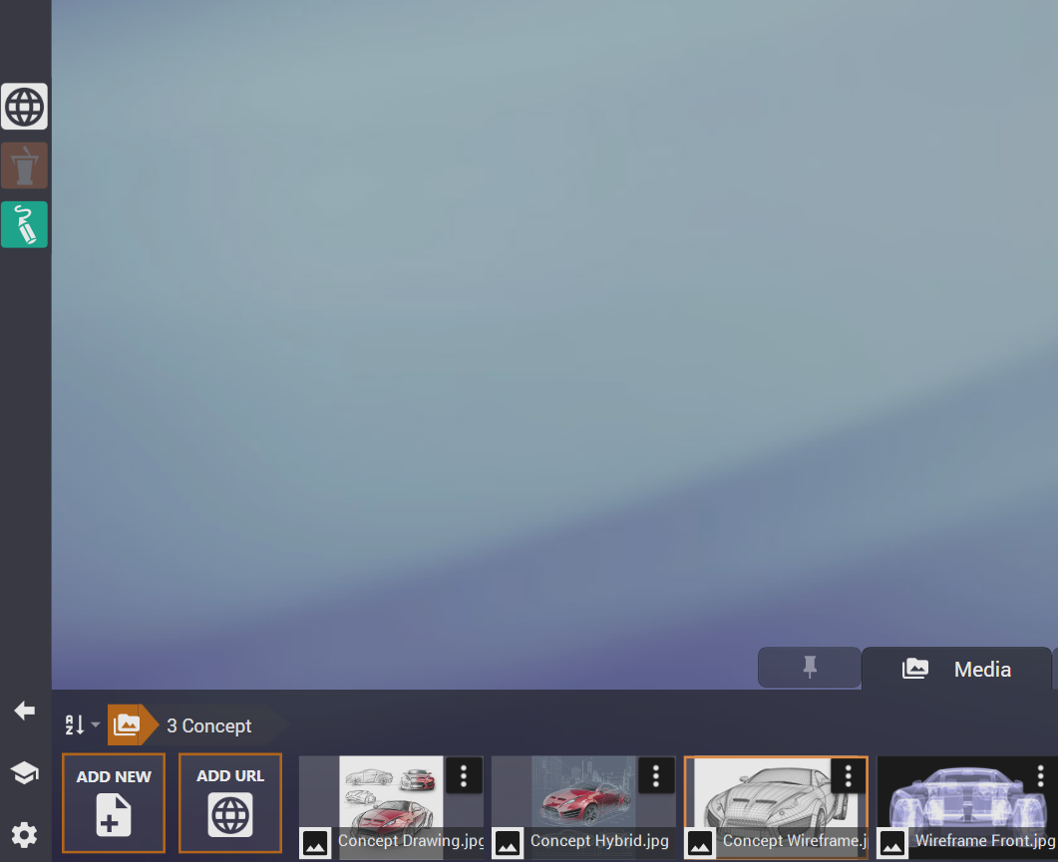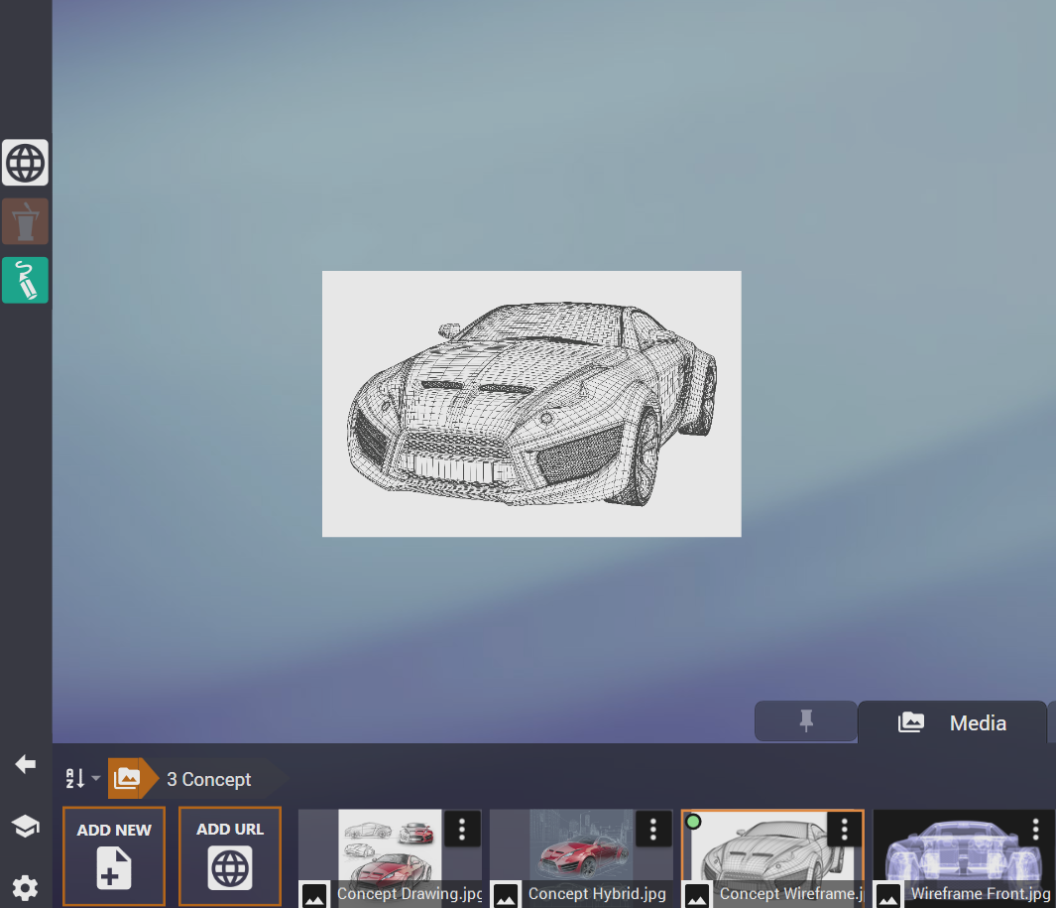
- New Hyperlink feature allows linked media from a document to be assembled as a scatter item. Users can pre-populate a document with a list of hyperlinks and quickly select their content without having to drag from the media dock.
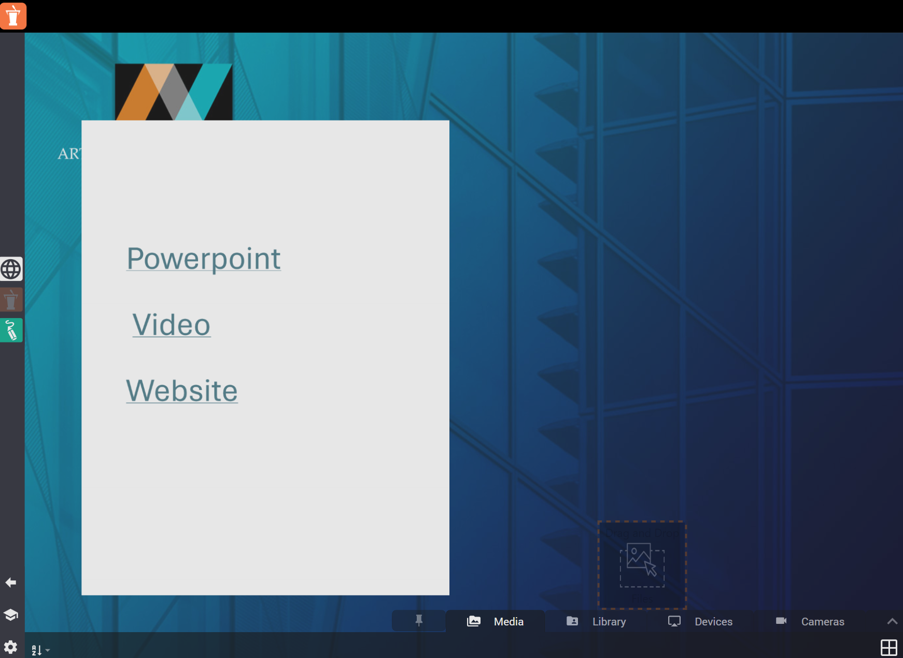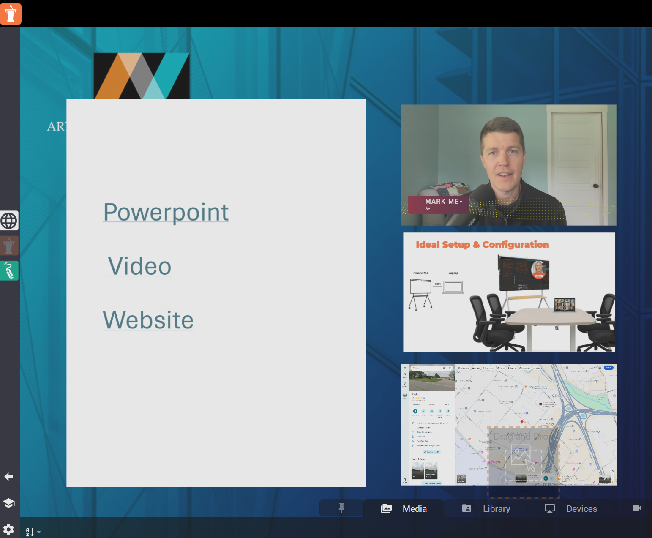
- Alphabetical sorting for STAGE layouts and the “Recent Layouts” list.
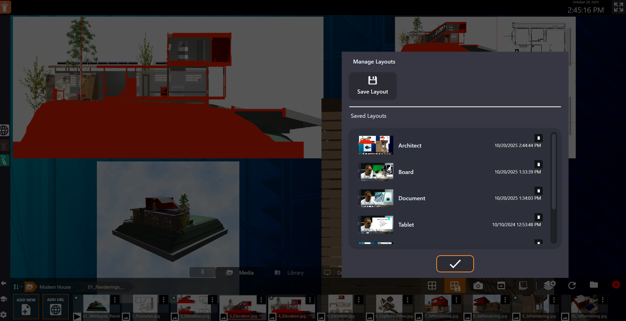
- Browser zoom can be controlled via the zoom slider and mouse wheel.
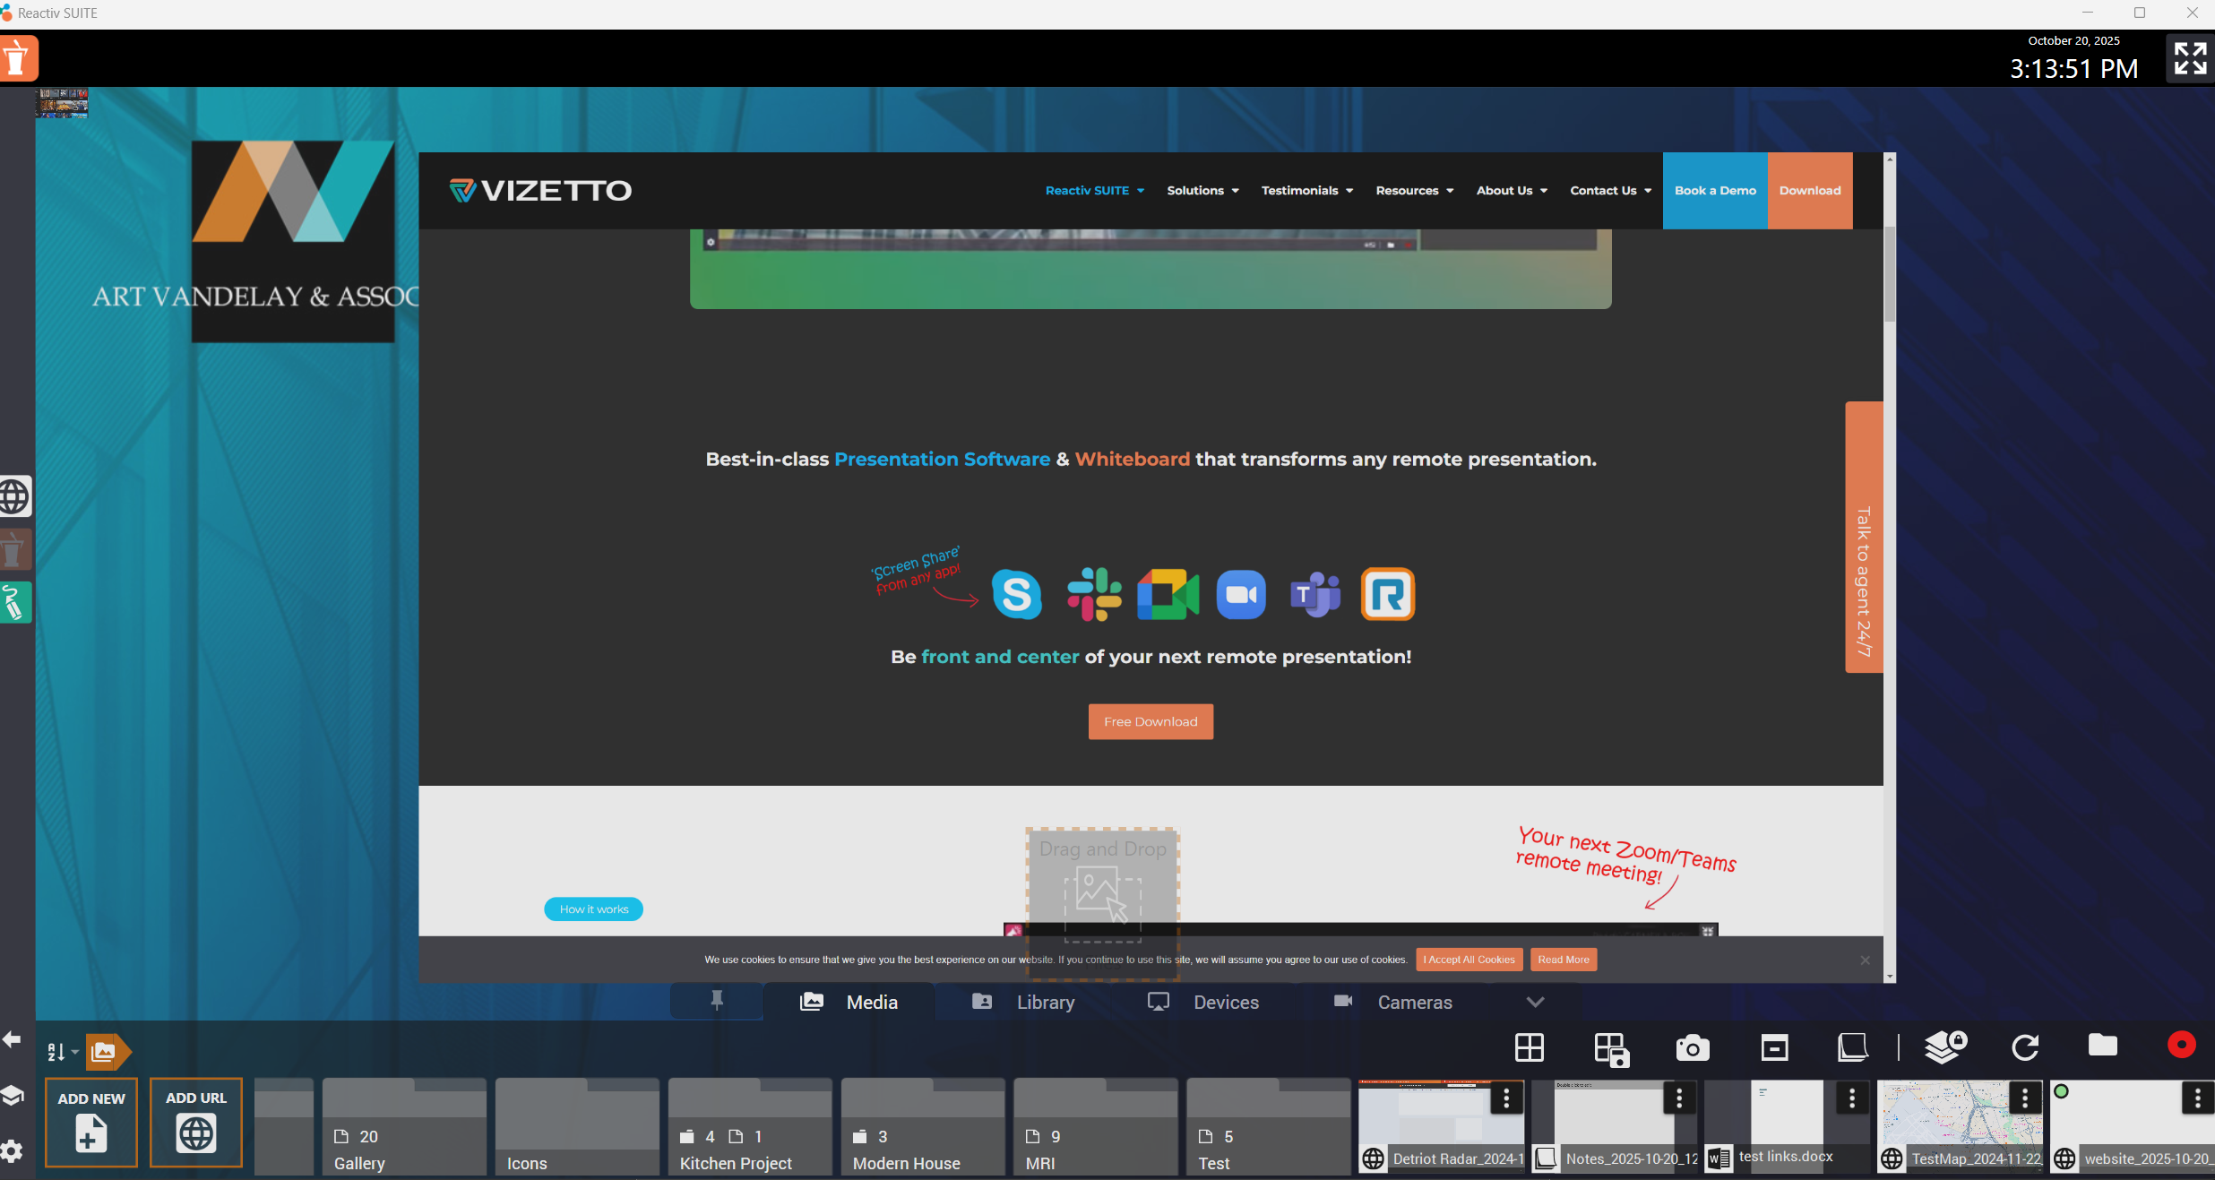

- Workspace creation is clearer: a new folder is created under the chosen parent, and you can edit the display name separately from the folder path.
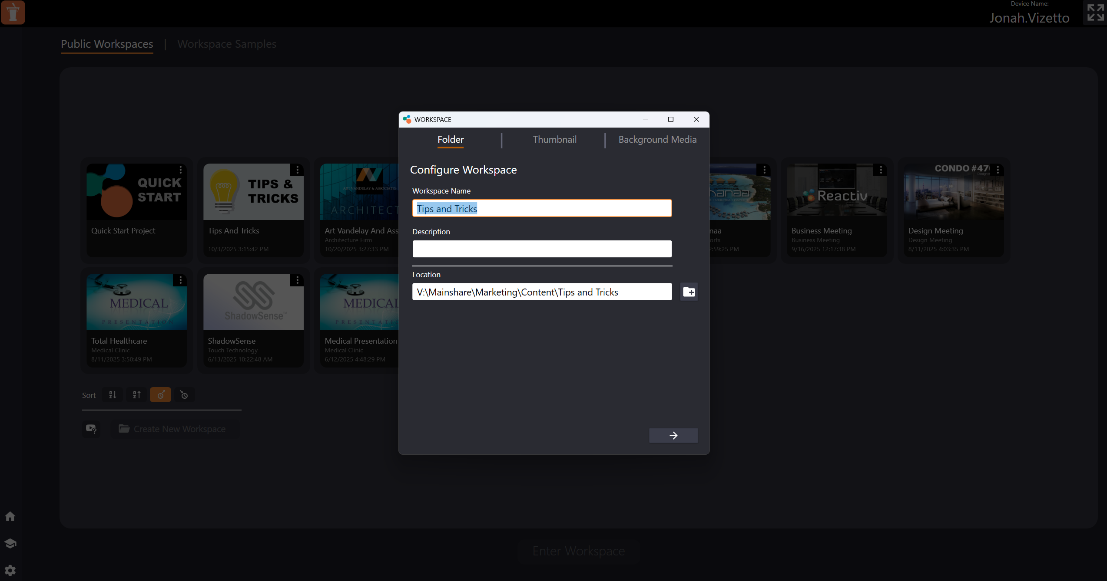
- Device list clarity: added a short unique ID to tell apart AV devices with the same name.
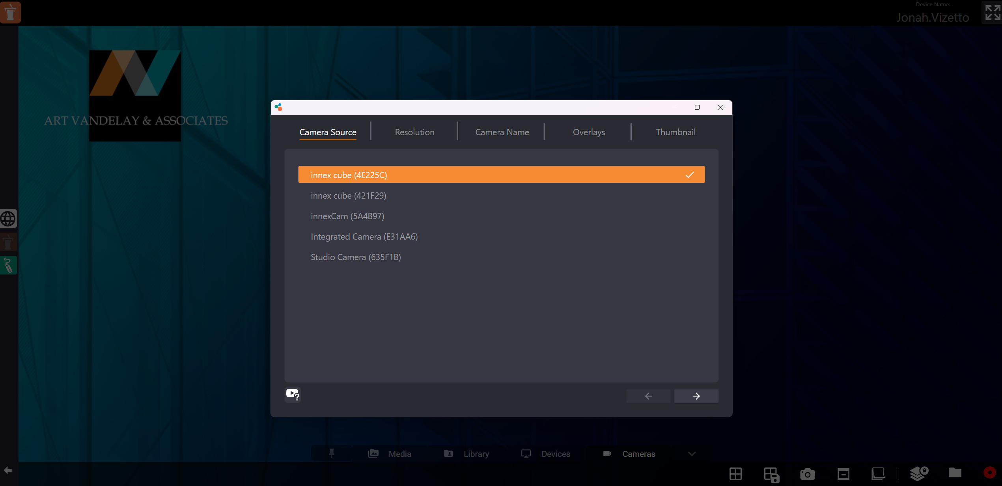

- Browser settings: “Clear cache” removes all data and can also clear cookies.
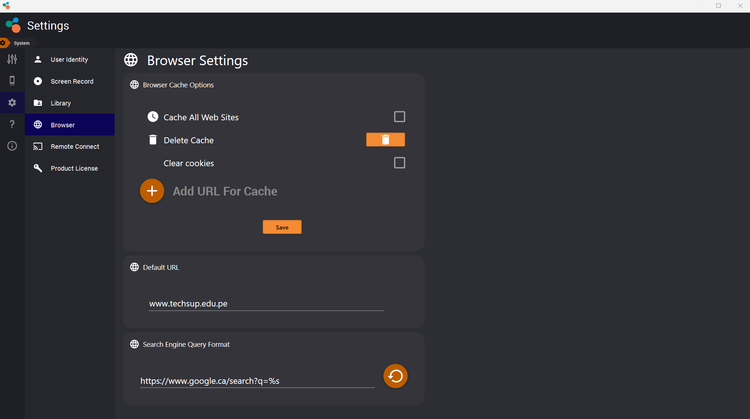
- Minor bug fixes to increase efficiency and reduce crashes.

